Name: ID:
Email:
Keystone Algebra 1 Review Module 2 2
Multiple Choice
Identify the choice that best completes the statement or answers the question.
 | 1. | A rectangle has an area of 24 square units. The width is 5 units less than the length. What is the length, in units, of the rectangle?  a. 6 c. 3  b. 8 d. 19
 | 2. | The bowling team at Lincoln High School must choose a president, vice president, and secretary. If the team has 10 members, which expression could be used to determine the number of ways the officers could be chosen?  a. c.  b. d.
 | 3. | The table below shows a cumulative frequency distribution of runners’ ages.  Age Group Total  20-29 8  20-39 18  20-49 25  20-59 31  20-69 35  According to the table, how many runners are in their forties?  a. 25 c. 7  b. 10 d. 6
 | 4. | Mr. Turner bought x boxes of pencils. Each box holds 25 pencils. He left 3 boxes of pencils at home and took the rest to school. Which expression represents the total number of pencils he took to school?  a. c.  b. d.
 | 5. | Lenny made a cube in technology class. Each edge measured 1.5 cm. What is the volume of the cube in cubic centimeters?  a. 2.25 c. 9.0  b. 3.375 d. 13.5
 | 6. | Which value of p is the solution of 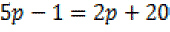?  a. c. 3  b. d. 7
 | 7. | The statement 2 + 0 = 2 is an example of the use of which property of real numbers?  a. associative c. additive inverse  b. additive identity d. distributive
 | 8. | Mrs. Smith wrote “Eight less than three times a number is greater than fifteen” on the board. If x represents the number, which inequality is a correct translation of this statement?  a. c.  b. d.
 | 9. | There is a negative correlation between the number of hours a student watches television and his or her social studies test score. Which scatter plot below displays this correlation?  a. c.  b. d.
 | 10. | When is subtracted from , the difference is  a. c.  b. d.
 | 11. | Factored completely, the expression is equivalent to  a. c.  b. d.
 | 12. | Factored, the expression is equivalent to  a. c.  b. d.
 | 13. | What is the product of and ?  a. c.  b. d.
 | 14. | Which value of x makes the expression 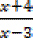undefined?  a. -4 c. 3  b. -3 d. 0
 | 15. | Which expression represents 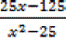in simplest form?  a. c.  b. d.
 | 16. | What is the product of and expressed in simplest form?  a. c.  b. d.
 | 17. | A swim team member performs a dive from a 14-foot high springboard. The parabola shows the path of her dive.  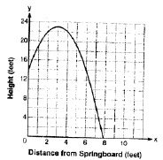  Which equation represents the axis of symmetry?  a. x = 3 c. x = 23  b. y = 3 d. y = 23
 | 18. | Which expression represents 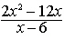in simplest form?  a. 0 c. 4x  b. 2x d. 2x + 2
 | 19. | Consider the graph of the equation , when . If a is multiplied by 3, what is true of the graph of the resulting parabola?  a. The vertex is 3 units above the vertex of the original parabola. c. The new parabola is wider than the original parabola.  b. The new parabola is 3 units to the right of the original parabola. d. The new parabola is narrower than the original parabola.
 | 20. | What are the vertex and the axis of symmetry of the parabola shown in the diagram below?  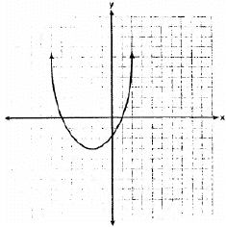  a. The vertex is (-2, -3) and the axis of symmetry is . c. The vertex is (-3, -2) and the axis of symmetry is .  b. The vertex is (-2, -3) and the axis of symmetry is . d. The vertex is (-3, -2) and the axis of symmetry is .
 | 21. | What is the product of 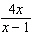and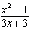 expressed in simplest form?  a. c.  b. d.
 | 22. | Is the equation equivalent to ?  a. Yes, the equations are equivalent by the Associative Property of Multiplication. c. Yes, the equations are equivalent by the Distributive Property of Multiplication.  b. Yes, the equations are equivalent by the Commutative Property of Multiplication. d. No, the equations are not equivalent.
 | 23. | 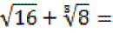  a. 4 c. 9  b. 6 d. 10
 | 24. | Which expression is equivalent to ?  a. c.  b. d.
 | 25. | 1. Which number does not have a reciprocal?  a. -1 c.  b. 0 d. 3

